C programming doc

First C program
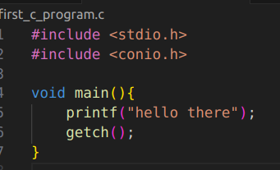

- #includes <stdio.h> : standard input/output library functions (printf)
- #include <conio.h> : console input/output library fonctions (getch())
→ We should avoid using <conio.h> and getch() because it’s not included in modern compilers
- void main() : void specifies that the main func returns no value
→ C standard specifies that main should return an int so it’s better to use int main
→ returning an integer indicates that the program terminated successfully (usually return 0 ;)
- printf() : used to print data in the console
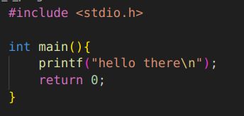

- In C we need to compile the source code into an executable before running it unlike in Go which has a go run command that allows to run Go programs whitout explicitly compiling them first

- We can create a run.sh script that compiles and run the C program in one step
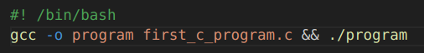

- Then give the permission to run it and run the program
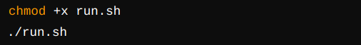

- We get this result
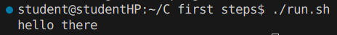

C tokens
- Tokens : the smallest individual units, there are 6 types of tokens in C

1) Identifiers
- Refer to the names of variables/constants/functions/arrays
- It can only have aplhanumeric characters and undersscore
- The first character can only be a letter or underscore
- Case sensitive : name and Name are 2 different identifiers
- Keywords can’t be used as identifiers
- No special characters are allowed
- C compiler only recognize the first 31 characters of an identifier
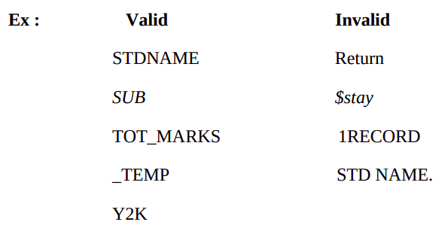

2) Keywords
- Reserved words : have a fixed meaning that we can’t change (basic building blocks for program statements)
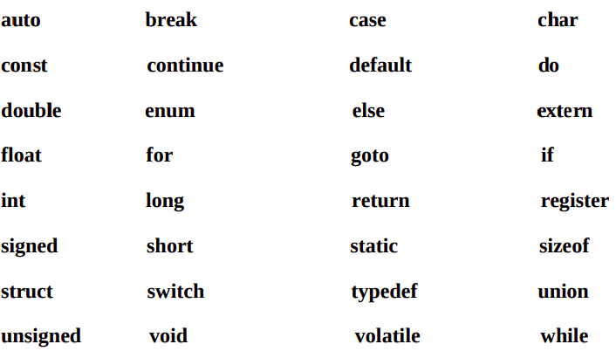
- They all are written in lowercase

3) Constants
- Also called literals : refers to a fixed value that doesn’t change during the execution of the program
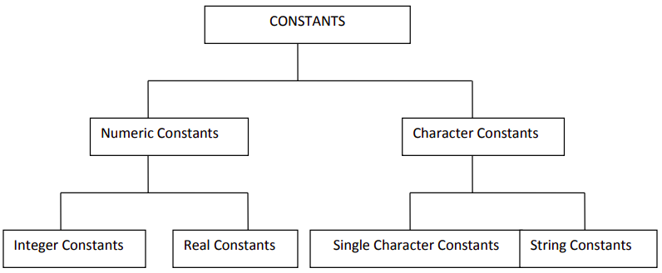

a) Interger constants
- numeric constant (without fractional/exponential part)
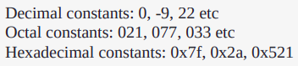
- 3 types :
→ Decimal constants (base 10)
→ Octal constants (base 8) : start with 0
→ Hexadecimal contants (base 16) : starts with 0x
- Decimal integer : (0-9), doesn’t start with 0, (signs ±), no special characters
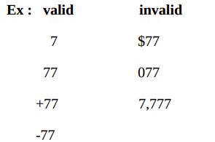

- Octal : (0-7), start with 0, signs ±), no special characters
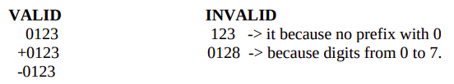

- Hexadecimal : (0-9),(a-f : capital/small letters), starts with 0X or 0x, signs ±), no special characters
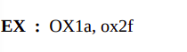

- Floating point/Real constant : fractional/exponent form
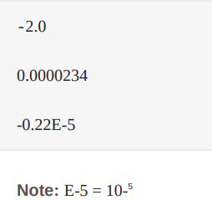

b) String constant
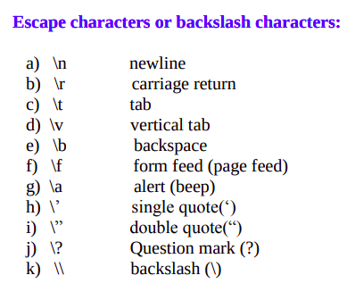

4) 2 ways to define constants in C
a) Whithout clearing the screen
